**Batch:H2-3**

**Roll No.: 16010122221**

**Experiment 08**

**Title: To create an effective Story in Tableau.**

# Objective:

1. *Search/locate and download any Data of Your Choice (Use same dataset if it contains location information)*
2. *To learn how to create Story in Tableau 3. Apply best practices to create Tableau Story.*

# Course Outcome:

CO2 Detect and understand the stories within datasets and its applications. CO3 Apply data visualization best practices

CO4 Design static charts, interactive Dashboards and data stories

# Books/ Journals/ Websites referred:

1. Data Visualization made simple New York: Routledge - Kristen Sosulski, First edition, 2019
2. Sosulski, K. Data Visualization Made Simple: Insights into Becoming Visual, First edition, 2018
3. https:/[/www.kaggle.com/uciml/](http://www.kaggle.com/uciml/adult-census-income)a[dult-census-income](http://www.kaggle.com/uciml/adult-census-income)
4. https://archive.ics.uci.edu/ml/datasets/adult
5. https://ori.hhs.gov/education/products/n_illinois_u/datamanagement/dctopic.ht ml
6. A review of research process, data collection and analysis - Surya Raj Niraula

# Resources used:

1. https:/[/www.kaggle.com/uciml/](http://www.kaggle.com/uciml/adult-census-income)a[dult-census-income](http://www.kaggle.com/uciml/adult-census-income)
2. https://archive.ics.uci.edu/ml/datasets/adult

# Theory:

A story is a sequence of visualizations that work together to convey information. You can create stories to tell a data narrative, provide context, demonstrate how decisions relate to outcomes, or to simply make a compelling case. A story is a sheet, so the methods you use to create, name, and manage worksheets and dashboards also apply to

stories. At the same time, a story is also a collection of sheets, arranged in a sequence. Each individual sheet in a story is called a story point. Storytelling is indeed a powerful force, and in the age of information, it’s possible to use the wealth of insights available at your fingertips to communicate your message in a way that is more powerful than you could ever have imagined.

A good data story leverages three major components:

Data, narrative, and visuals.

The data component is simple, we must have the accurate data, to reach correct insights. The visual component enables us to spot trends and patterns in datasets, which are not easily seen in the rows and columns of spreadsheets.

Data storytelling is about communicating your insights effectively, giving your data a voice. The narrative components which concern the simple language used to describe the data can be seen as giving a voice to the data. Each data point is a character in a story - a protagonist - with its own story to tell. Combined together, narrative, data, and visuals can create data stories which drive change in businesses

# Implementation:

Best Practices for creating stories:

Use stories to make your case more compelling by showing how facts are connected, and how decisions relate to outcomes. You can then publish your story to the web, or present it to an audience.

Each story point can be based on a different view or dashboard, or the entire story can be based on the same visualization seen at different stages, with different filters and annotations. A good data story brings data and facts to life. Some of the best practices have been mentioned below.

* 1. Understand your story’s purpose: Before you start to build your story, take some time to think about the purpose of your story and what you want your viewers' journey to be. you're presenting a case, decide whether you want to present data points that lead up to a conclusion at the end, or start with a conclusion then show the supporting data points.
  2. Keep it simple: A common error is trying to cram too many views and dashboards into a single story. The result is too many points for your viewers to take in.The clarity of each story point is also important. Take a step back and consider your story from the perspective of someone who's never seen it. Every element should serve a purpose. If captions, titles, legends, or grid lines aren't necessary, get rid of them!
  3. Use ‘Fit’ in dashboards: Dashboards are a common ingredient in Tableau stories. For dashboards that you plan to include in your story, you can use the Fit to option under Size on the Dashboard pane. It will resize your dashboard so that it's the right size for the story you're creating.
  4. Plan for fast load times: The most wonderful story in the world won’t have much impact if it takes too long to load once it's published. People find long waits frustrating.Filtering is a common culprit for slow load times. Although filters are effective in restricting the amount of data being analyzed, they also impact

query performance. For example, Exclude filters tend to be slower than Keep Only filters. This is because Exclude filters load all of the data for a dimension instead of just what you want to keep.

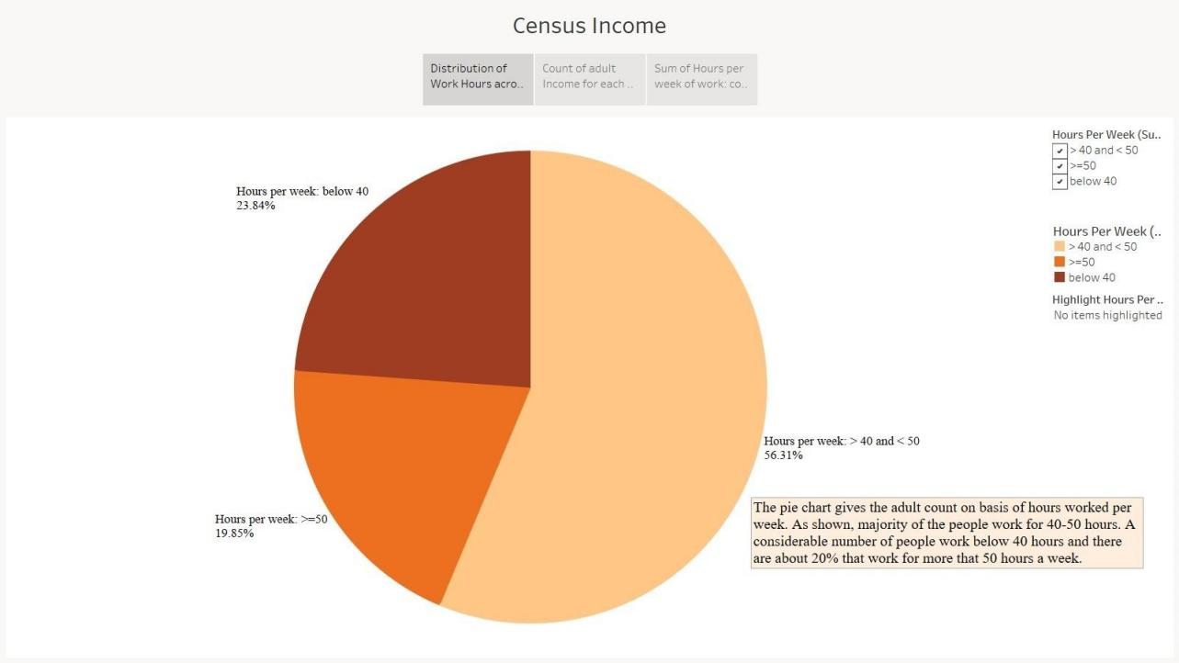

The pie chart gives the adult count on basis of hours worked per week. Maximum people work for 40-50 hours. The pie chart seems to be better than the line chart as shown above as it gives a clear indication of the people working for different hours and is visually appeasing. It gives us a clear picture of the work hours of the adult and compares the population count on that basis. This chart also has a filter to provide comparison between 2 or more categories of people.

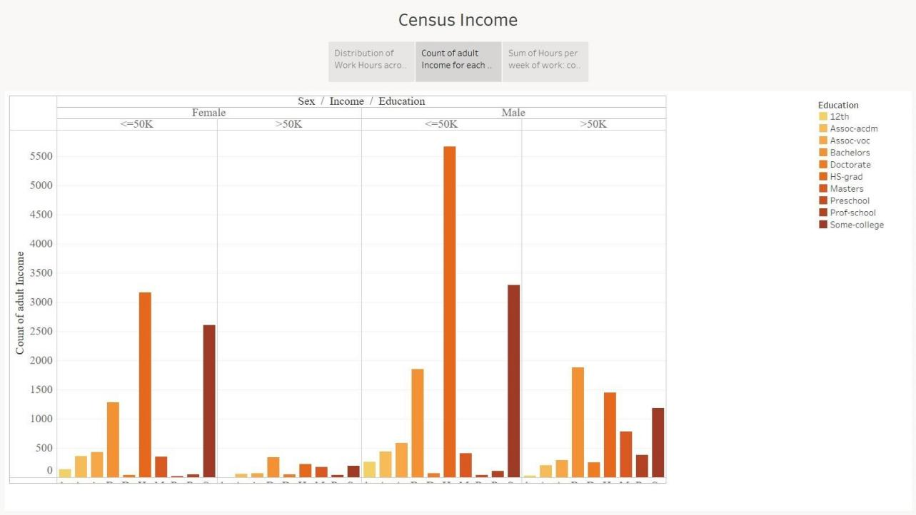

The chart above shows the comparison of income between males and females according to their educational qualifications. This is a bar chart where each bar has a color corresponding to the educational qualifications as shown in the legend. There is also a demarcation between males and females and their income on basis of population count.

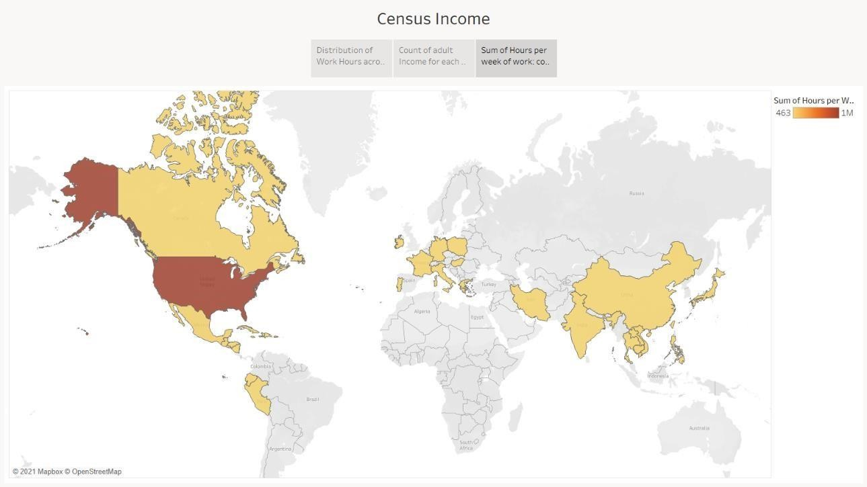

The above graph is a geospatial graph. It shows comparison of total work hours of the population in the regions. This helps give a clear idea of income of population based on the work hours and makes analysis efficient.

# Conclusion:

Through this experiment we learnt about the concept storytelling and learnt to explain our dashboards in an effective way to explain our topic at hand – “Adult Income” and how other factors affect it.

# Date: 24-11-2021 Signature of faculty in-charge

**Post Lab Question:**

# 1. Explain the need of story in your words.

To minimize the audience’s getting “lost in the data,” effective data storytelling requires not only using the right tools but also employing best practices. There are a host of factors that impact the effectiveness of conveying your message.

Good data storytelling is even more important today. Clearly conveying the meaning of data has never been more key than during the Covid-19 crisis. As we demand answers

and assessments of the pandemic’s threats, the public have relied on people who can communicate both findings and uncertainties in understandable ways.

Great data storytellers have demystified complex concepts such as exponential curves and logarithmic axes. The media have been adept at turning data into stories about trends and movements and the impacts of changing lockdowns. More recently we have moved from data about the disease to the impacts on our economy.

We use data to find and share insights to persuade, inform and drive change. Having a full stack of data collection, storage, processing, and analysis is of no use if you and your employees do not know how to use that data to have conversations or to make decisions. Data storytelling turns data from neutral fields in a database into opinions, arguments and insights.

Only by elevating data culture and educating on digital literacy across the board will we enable individuals to do more engaging and meaningful data storytelling, and in turn, to get a better return on your investment.